**﻿Issues or errors I faced ﻿during the development process and how I rectified those ﻿issues or errors:**

**Issue 1:**

The contact form (picture below) was not functional initially.

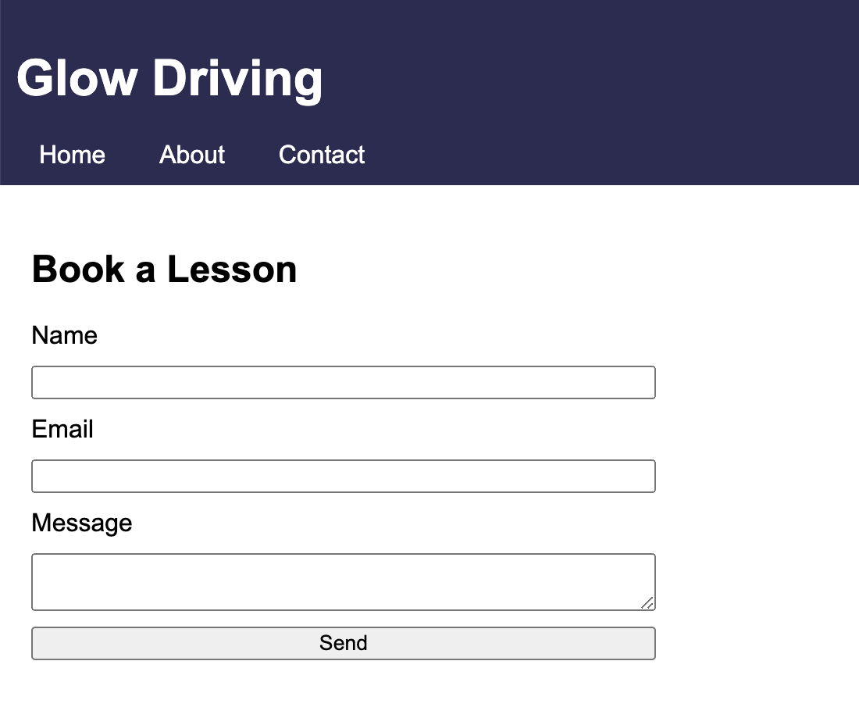

**how I rectified this ﻿issue:**

Step 1: I have signed up for a free account in Formspree, generated a unique endpoint URL from them (picture below)

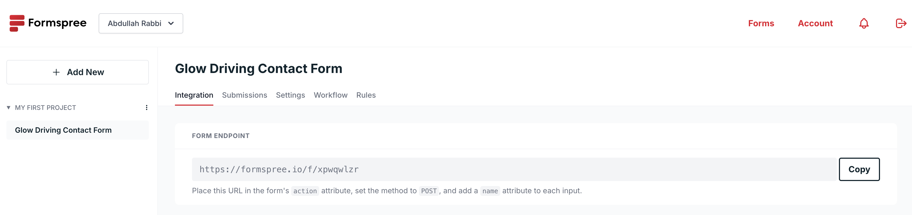

Step 2: added this unique endpoint URL (<https://formspree.io/f/xpwqwlzr>) to my contact.html file (picture below)

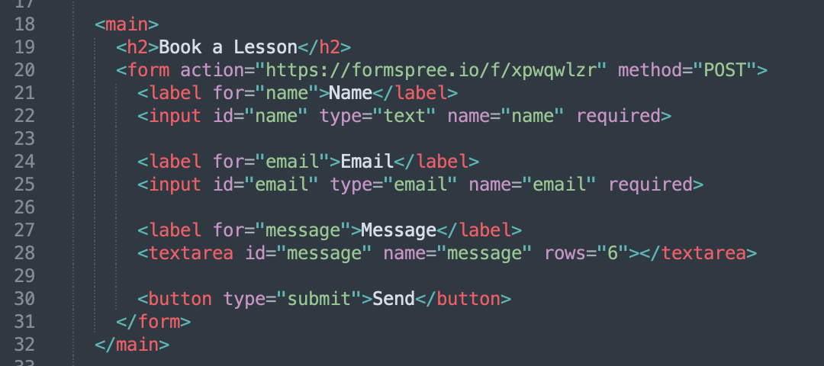

Step 3: Now, if someone fills up the contact form and presses the “Send” button, I receive their information/message in my email through Formspree (picture below)

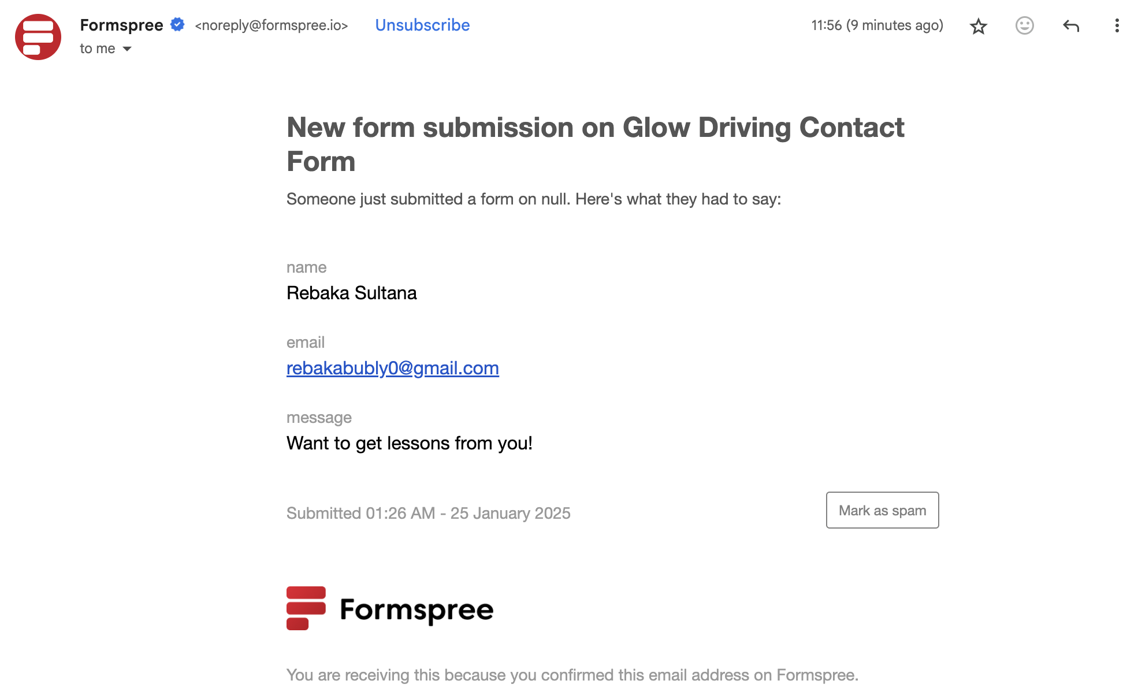

**Issue 2:**

My website’s pages had no favicon initially (pictures below):

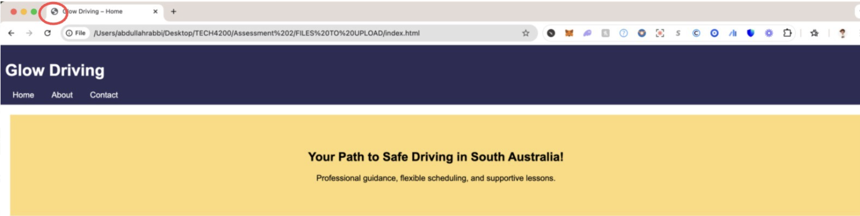

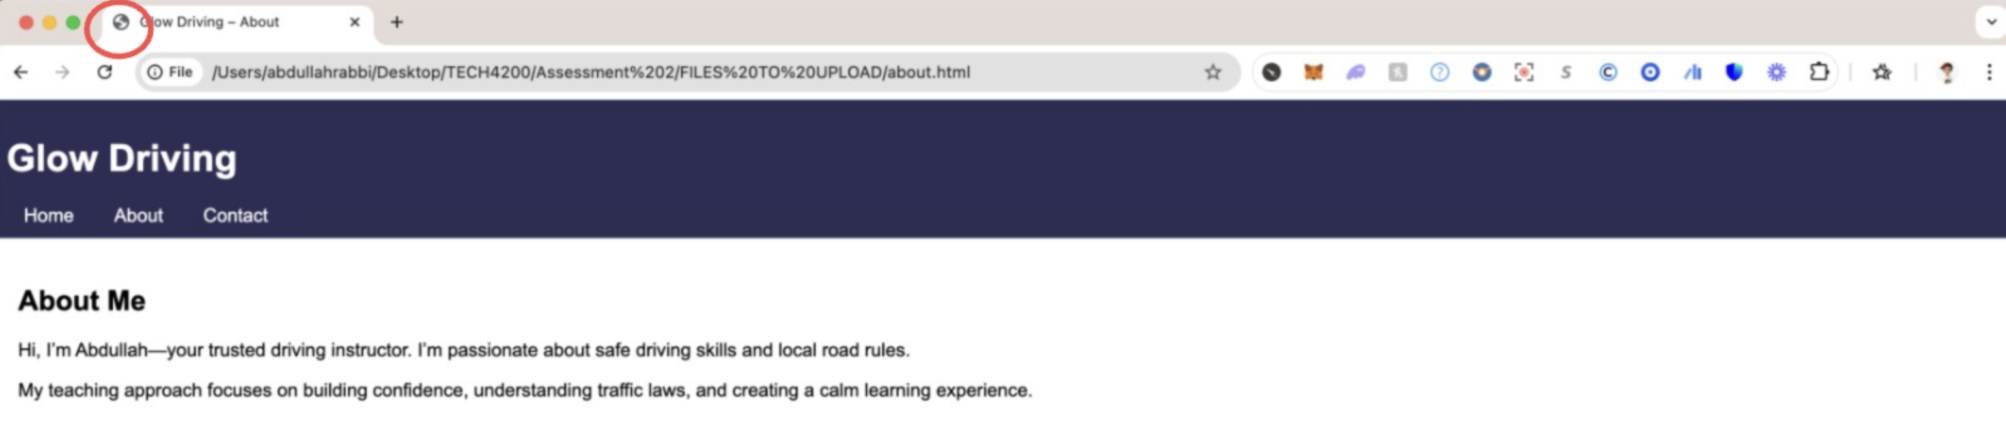

**how I rectified this ﻿issue:**

Step 1: I have used a free tool named **favicon.io** (<https://favicon.io>). From there, I have created and pasted two files named favicon.png and apple-touch-icon.png in the same folder where my HTML files are available.

Step 2: After that, I had to make some changes in my codes in all HTML files. Basically, I had to write two more lines between my opening <head> tag and my closing </head> tag to make both Favicon and Apple Touch Icon work (picture below)

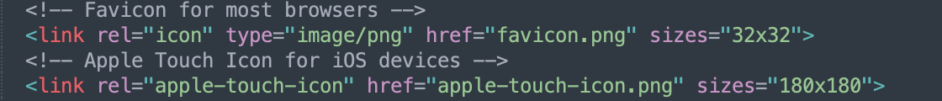

Step 3: After that, my all webpages are showing my desired favicon (picture below)

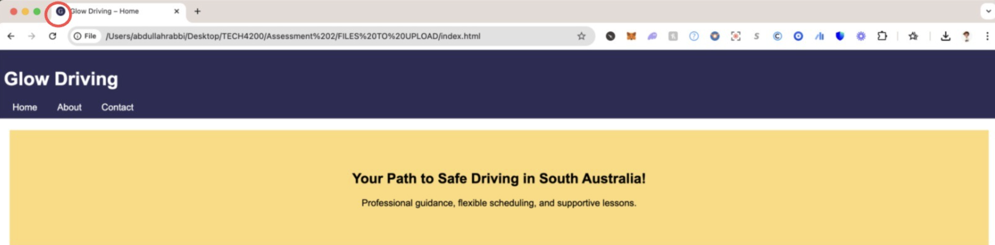

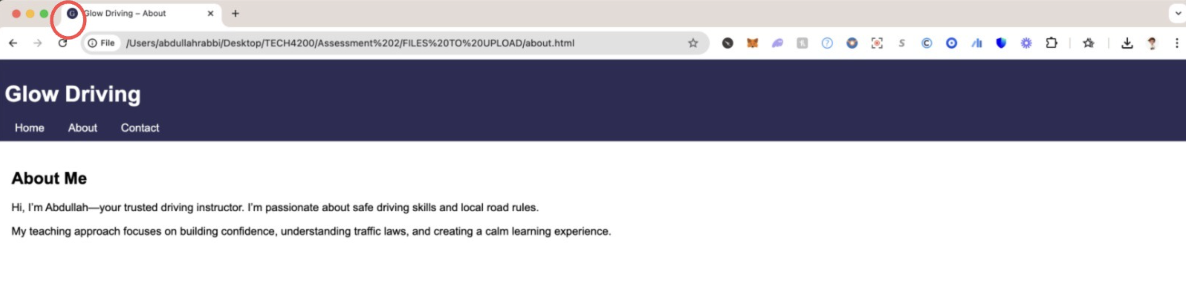

Step 4: I have also tested that whether the Apple Touch Icon for my webpages are working on not. After hosting my webpages locally on my Mac’s local IP address, I have seen that Apple Touch Icon is also working (pictures below)

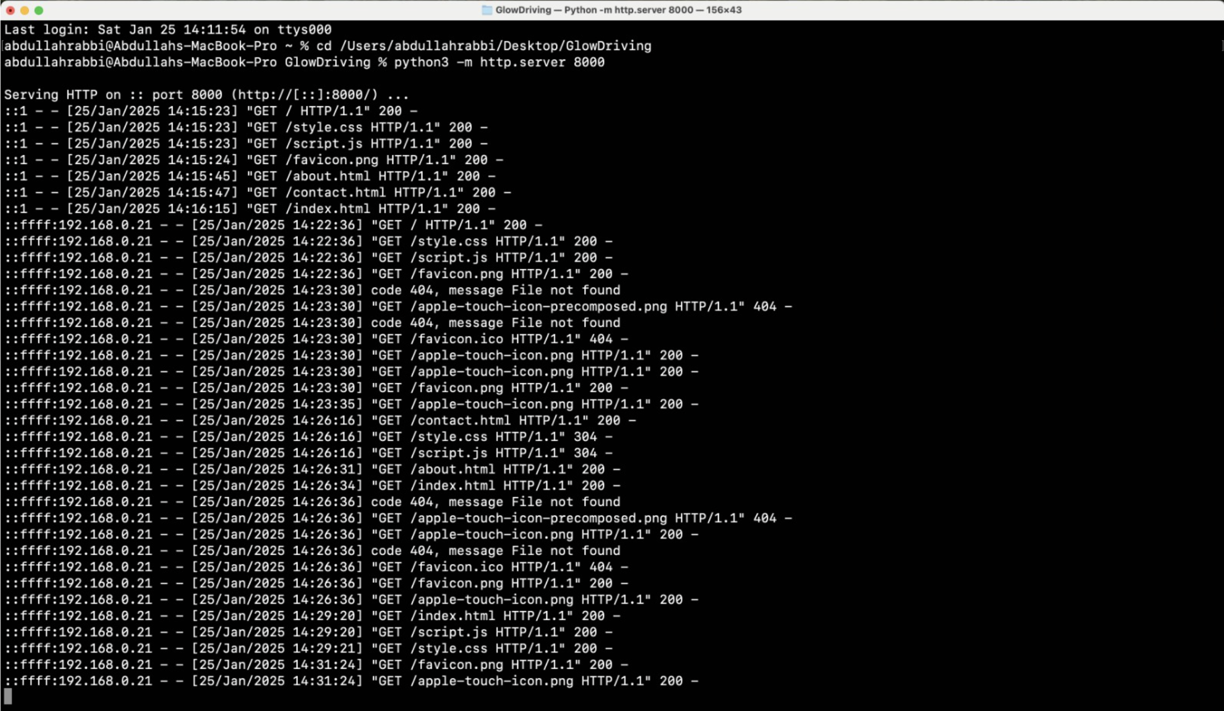

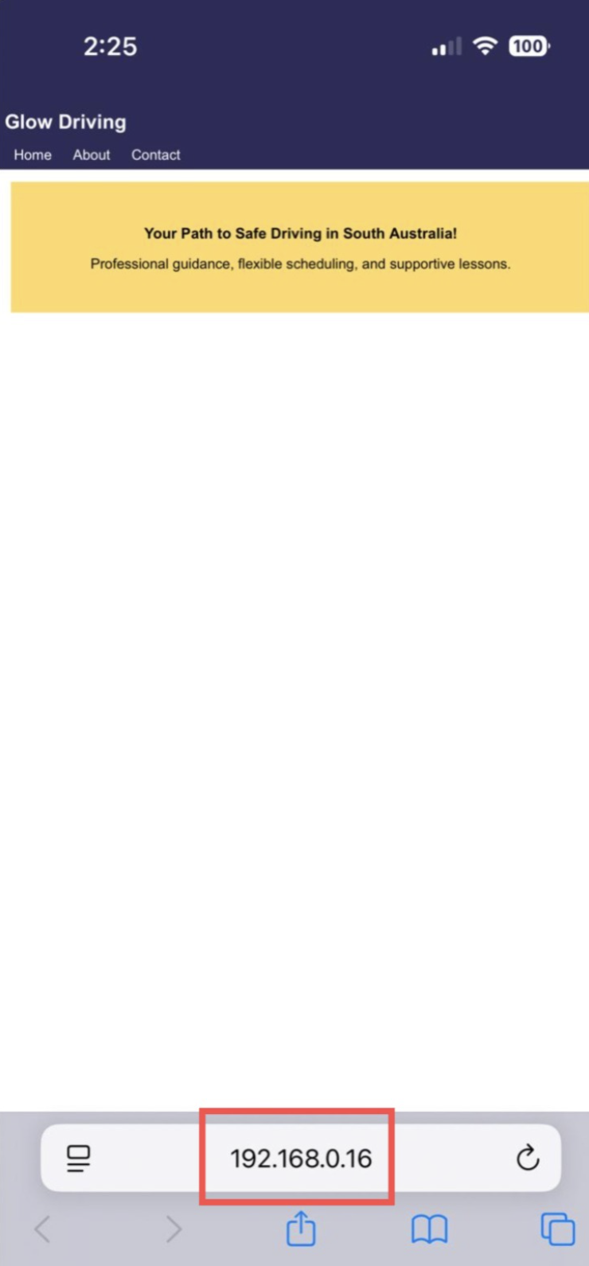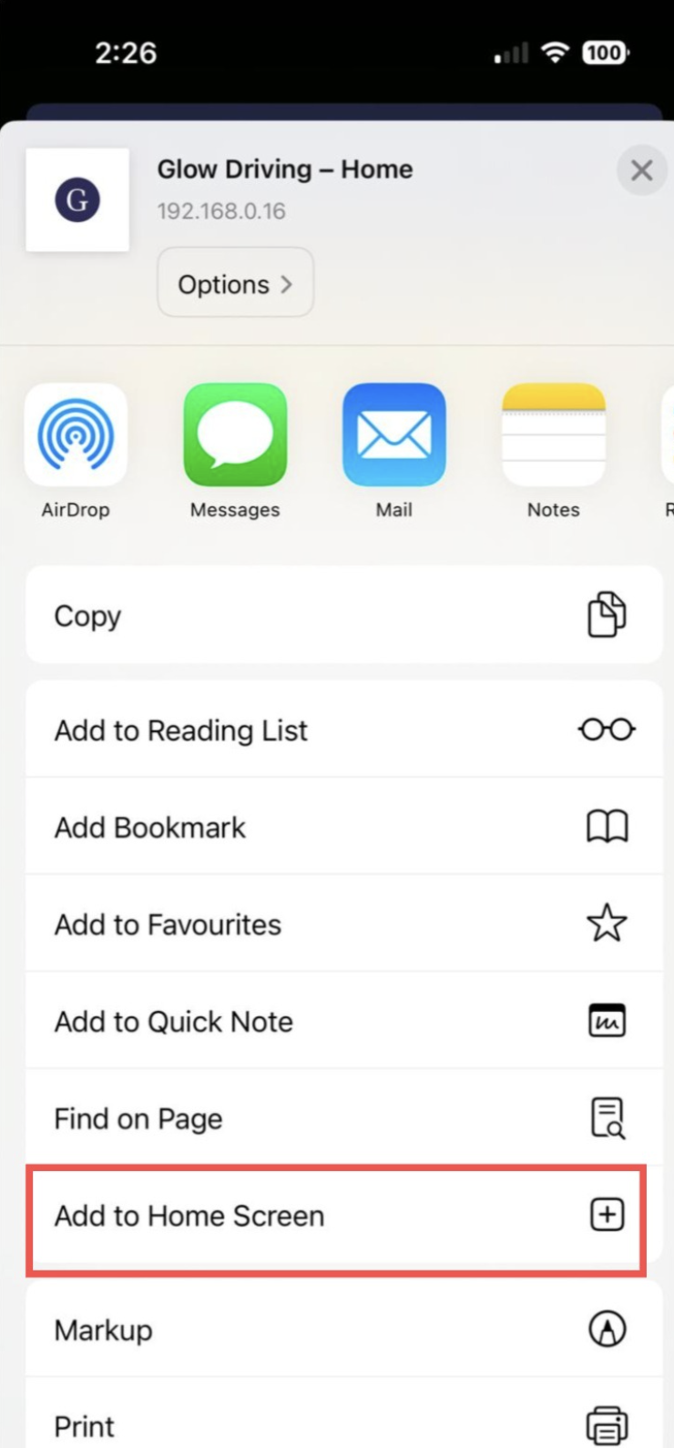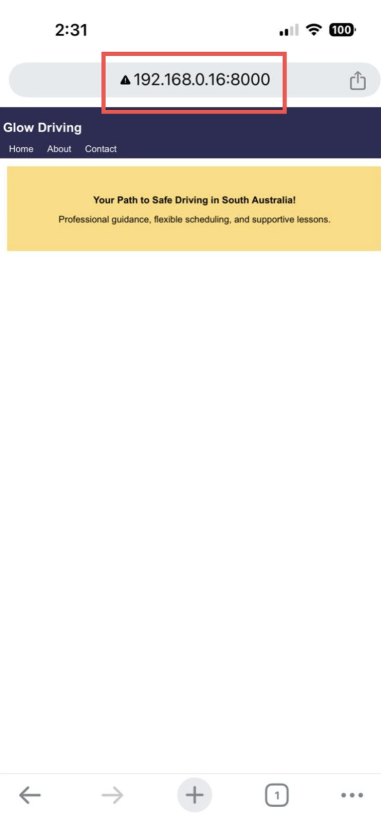

Step 5: to make the webpages publicly accessible, I have uploaded the files to GitHub Pages as well. The website can be viewed at <https://aarhira.github.io/GlowDriving/>

**Issue 3:**

The website’s font was not visually appealing initially (picture below)



**how I rectified this ﻿issue:**

Step 1: In my <head> section, I have added the Google Font (picture below) to make the font beautiful.

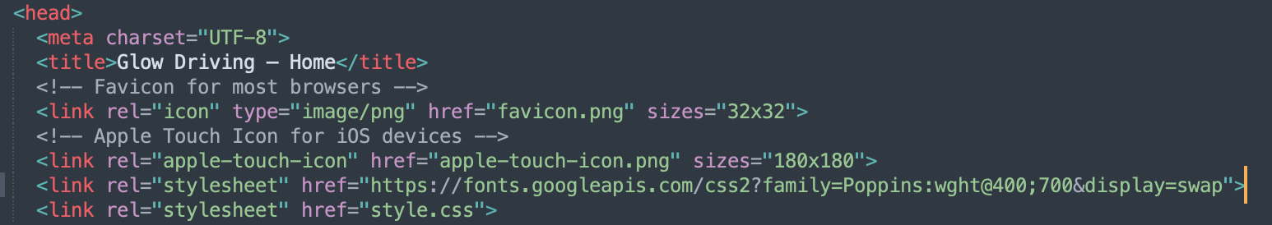

Step 2: then in my CSS, changed the font-family to 'Poppins'. It made all pages font more visually appealing (pictures below)



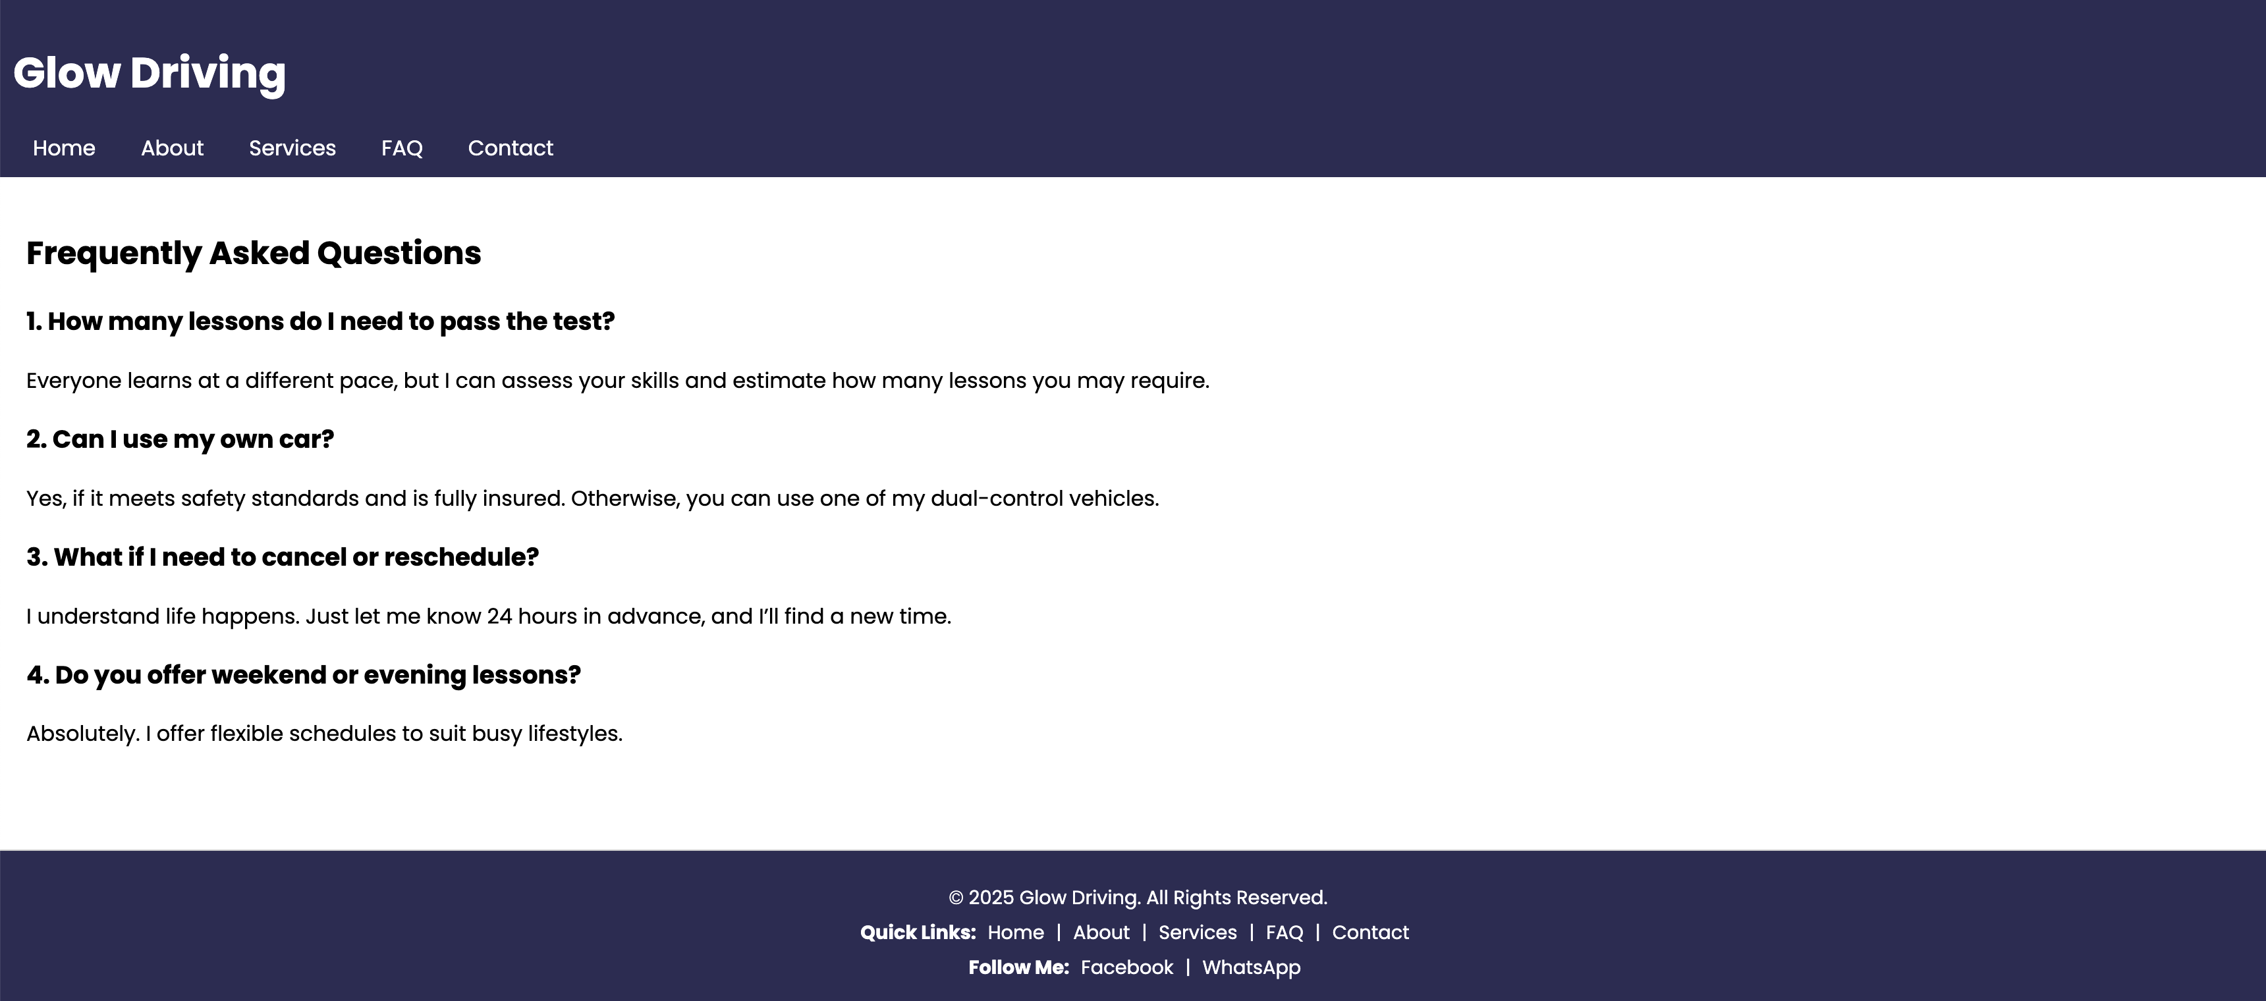

**Issue 4:**

Initially, anyone could submit the form, without typing any messages (images below)

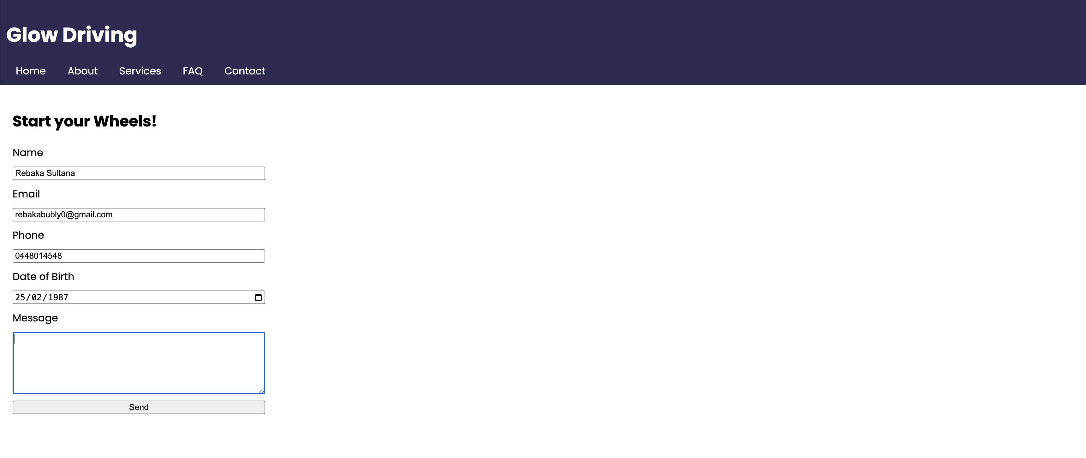

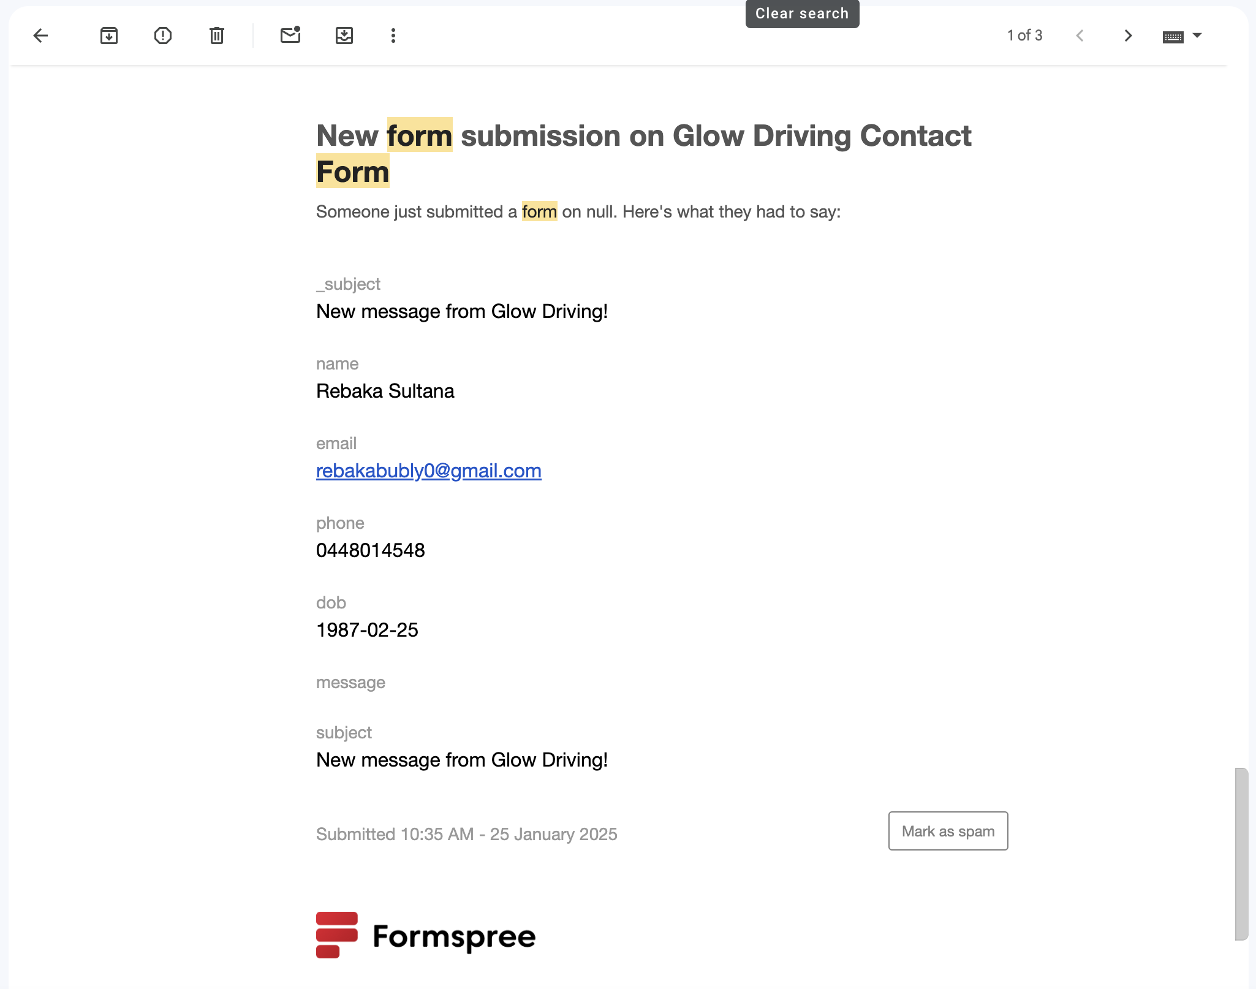

**how I rectified this ﻿issue:**

Step 1: I have added some extra JavaScript codes in my script.js file to make the “Message” field mandatory before submission. Also, I have added two checks for minimum and maximum character length in the “Message” field (code screenshot below).

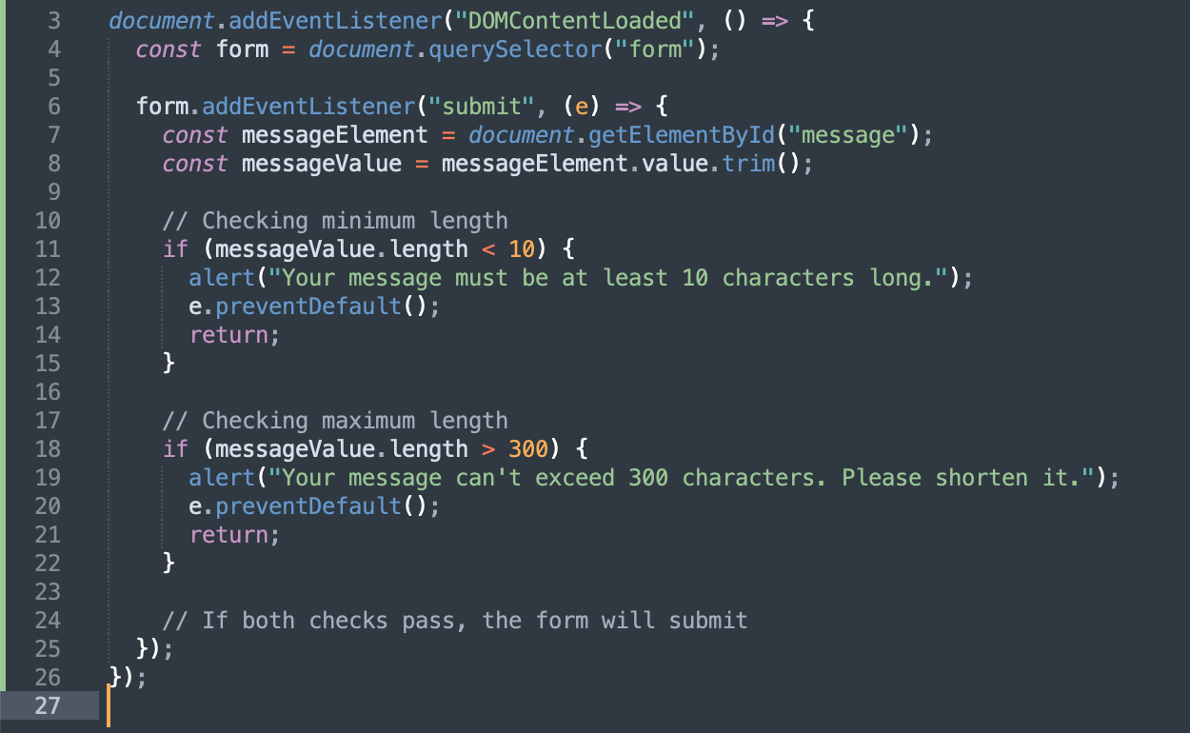

Step 2: After implementing these codes, if someone tries to submit the form without meeting the “Message” field requirements, the page will show error notification (picture below)

